**Deepak Gavit , Rahul Nagpure, Mandar Kalse, Harsh Poddar**

Department of Computer Science and Engineering

Vishwakarma Institute of Technology,pune

[1]

Smart Parking System Using IOT

.

*Abstract*— The rapid urbanization and increasing number of vehicles have led to a critical challenge in managing parking spaces efficiently. Conventional parking systems often result in congestion, wasted time, and environmental pollution. So there is need for a smart parking system which will help them manage the traffic in a better way . Existing systems exhibit limitations in optimizing resource allocation and providing timely information to drivers, resulting in heightened frustration and ecological impact. In response to these problems listed above, the proposition of a Smart Car Parking System utilizing Internet of Things (IoT) technologies emerges as a pioneering solution. This system has leveraging advanced features such as sensors, cameras, and real-time analytics, endeavors to redefine the dynamics of urban parking

***Keywords*** *—* (**car, car parking, smart car parking, iot, automation, website**)

1. **INTRODUCTION**

The first thing that makes the project different is the concept of UPI. The Unified Payments Interface (UPI) has become a significant and transformative force in the realm of digital payments in India One of the things that it has done is simplified transactions which has made a lot of peer to peer transactions user friendly. Also it is the security factor of UPI through multi-factor authentication, including device ID, PIN, and biometrics. This ensures a high level of security, mitigating the risks associated with digital transactions. In summary, UPI has significantly impacted the digital payments landscape in India, fostering financial inclusion, simplifying transactions, and contributing to the nation's journey towards a less cash-dependent economy. These were the reasons that tempted us to us

To use this feature so that we can make our parking system better than the previous ones Another big issue is regarding the parking slot pricing where in it takes plenty time to determine the price of how much the person has to park where major chunk of models adapt taking amount for bulk of time then always some time goes waste with no car at that slot and the excessive spending of the user.So for that we have thought of dynamic pricing by which the user pays the money according to hours and half hours so the pricing would be more efficient and they wont have to pay for any extra time.Then one of the most important factors in a parking system that uses iot is they use ir sensor not only for checking but also for the security purposes but there is a problem because the sensor only checks until a certain area and not after that, so we have thought of a image sensor at the entry as well as exit point which will be more secured for any kind of theft in the system.Also many times the user has to search a lot roaming everywhere whether they can find a parking so another feature is of a notification in which they will be alerted already that there is a parking slot available and if they are not interested they can anytime turn off the notifications and then turn it on when needed,that will reduce their troubles.

Now one final problem that always will occur is how to provide people all of these facilites .The best option that was sought is a website which will display all of the details at one place with safe and secure login system followed by their acoount details and displayin the features availibilty ,the dynamic pricing that needs to be paid at the end ,the UPI system can be integraded using API which will help it take place smoothly on the website not bothering the user to go at various places for various features.Data analytics can be further used which will analyze data collected on the parking usage patterns to optimize layout ,pricing strategies and overall optimal efficiency that will make the model work better to help the people.

# **RELATED WORK**

P. Eswara ,A V M Manikandan ,Saurabh Godha” model of associate underground multi-storied machine-controlled automotive parking system” [1] , This work proposes to develop associated implement a model model of a cheap and non human interference automotive parking system microcontroller. Model developed for underground automotive parking with many floors, prevents the usage of the car parking zone at ground floor. Entire method was controlled by a machine so it reduces the time wasted by someone to park a automotive. This model uses 2 circular floors, with six car parking slots in every floor. This mechanism has centre primary shaft to hold a raise to move the vehicle to its proper parking slot. various sensors, motors and package were used to transport the automotive to its allotted parking slot. Hence, this method provides a closed loop system management, creating it quite economical, accurate, secure and a convenient methodology projected for parking cars in both business and residential areas

TejasPund, Harshavardhan Sidagam, Asif Pinjari, “IOT Based Smart Parking System using NODEMCU” [2] , The paper first talked about how the rise in industrialization has led to more and more vehicles in any part of the world or even the country and along with that comes the problem of handling and parking them. Then later they talked about their system in which the IR sensor is used to track the entry or exit of a vehicle and then it is displayed to google firebase using internet so anyone can see anytime.

Hardik Tanti, Pratik Kasodariya , Shikha Patel , Dhaval H. Rangrej , Laxmi Institute Of Technology, Sarigam

” Smart Parking System based on IOT” [3] In this paper Author Explained briefly about growth of IOT has played a key role in solving majority of human problems and continues to do daily. They came up with a system where each parking lot will be monitored with some control system to get the status of the area whether it is empty or there is a car in that place and an application was developed which gave information about it and was also used for payment system for that particular area according to the time car will be parked.

Manickam Ramasamy, Sunil Govinda Solanki, Elango Natarajan “IoT Based Smart Parking System for Large Parking Lot”, [4] In this paper author explained about how we can overcome the conventional way of parking by IOT and cloud computing.they have used Arduino mega as a microcontroller to upload information of available parking space . So occupancy of parking slot is detected by ultrasonic sensor and notifies it Also servomotor opens the barrier at the entry and exit point when a car is detected.if Space is Occupied then the system will update it to cloud.

Vaibhav Hans, Parminder Singh Sethi, JatinKinra “An Approach to IoT based Car Parking and Reservation system on Cloud”, [5] In this Paper authors briefly explained about IOT based car parking system and reservation system ,based on cloud. Basically they focused on two different modules first one focuses on current demands of customers and the second one describes organization it basically organizes the space available for upcoming cars and keeps track of it. Also they have made a special wallet feature for payment purpose so No need to wait in queues to pay. Also they created a App through which we can keep track of our vehicle and we can do bookings from it. Cloud factory is used for Storage and parking is allocated when server side script runs.

Anusha, Arshitha M S, Anushri, Geetanjali Bishtannavar, Ms. Megha D Hegde” Review Paper on Smart Parking System”[6].The paper first talked about the problems of heavy traffic as well as the parking issues in metropolitian cities. The paper proposed a smart parking system tht was based on Arduino components embedded along with mobile application. The model uses onsite deployment of various slots that monitors the empty and filled slots signaling it through a mobile application. This made it easier for the user to directly first check on that app for empty slot rather than wasting time ,fuel to check.

Dipali Balmiki , Manas Singhal , Anupama Singh , Divyangi Tyagi “A Research On Smart Vehicle Parking System”[7].This system was developed with the thought of reducing the pollution and consumption of fuel. There are two main concepts ,first one is of Bluetooth model in which using the Bluetooth parking slot would be found in the nearest area and guided to the person. Second is a RFID tag which will be special for every car that will help to uniquely identify them after entering and before exiting.All this will be with image processing that will be at the opening gate scanning the car number plate to give entry

Ahmad Ihsan, Nurul Fadillah, C R Gunawan, Mursyidah Mursyidah “Detection of Empty Slots in Car Parking System Using Neural Network Method ”[8]This paper explained the importance of finding an empty slot in multicomplex buildings where it is difficult for humans to monitor. So they tried neural network which is one of the information processing systems designed by imitating the workings of the human brain in problem-solving. The purpose of this research is to determine which car parking slots filled or empty parking slots. This was carried on a system of 20 parking slots to detect which are empty and which are full with overall average accuracy of 95%

# **METHODOLOGY**

The development approach for the Smart Parking System involves a thorough process, incorporating in-depth requirements analysis, strategic planning of system architecture, and the integration of diverse IoT hardware elements for complete automation. The focus is on creating an intuitive interface, implementing robust functionalities, and ensuring secure user authentication. The system comprises real-time management of parking slots, validation of bookings, seamless payment integration, and an administrative dashboard for effective monitoring. Extensive testing and meticulous deployment precede user training, comprehensive documentation, and ongoing maintenance. Regular feedback from users and administrators is actively sought to facilitate continuous improvements. The project's scalability allows for easy adaptability and potential expansions in the future, providing a user-centric solution for efficient parking management through cutting-edge IoT technologies.

# **PROPOSED ARCHITECTURE**

Block Diagram :  
  
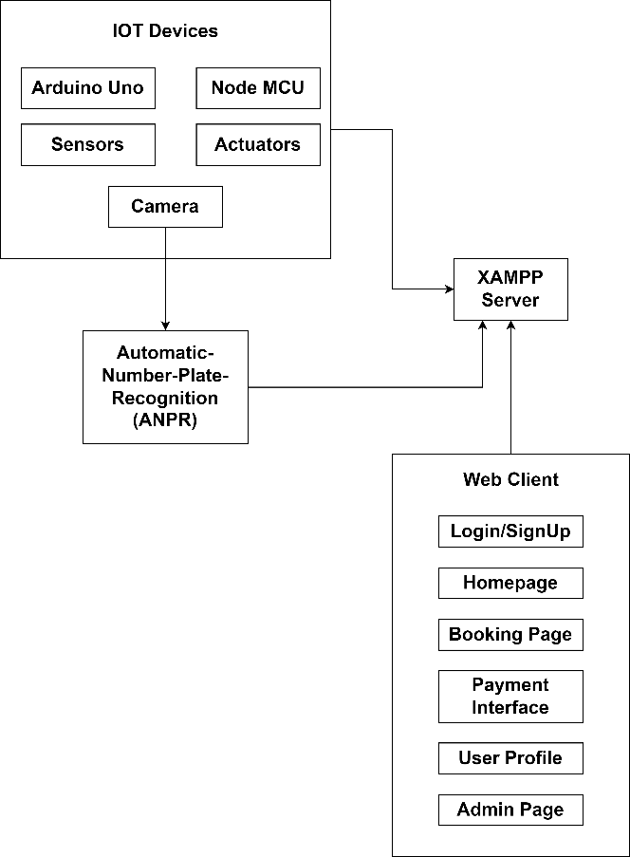

Flow Diagram :   
  
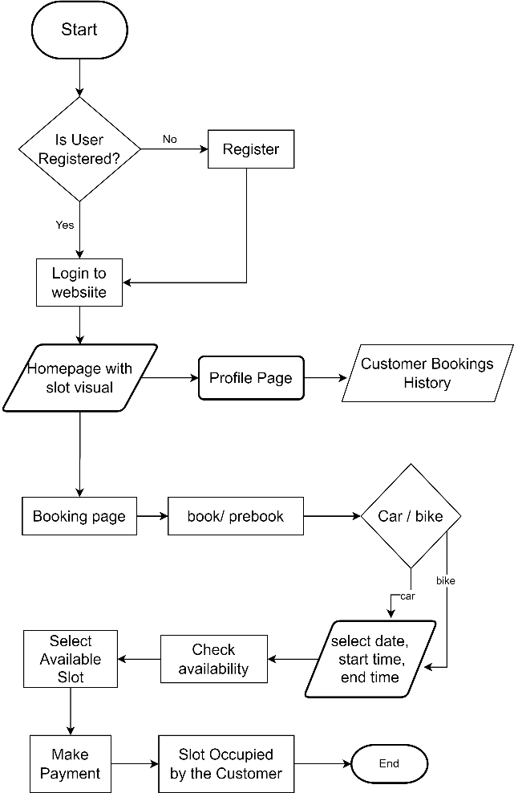

# **RESULT**

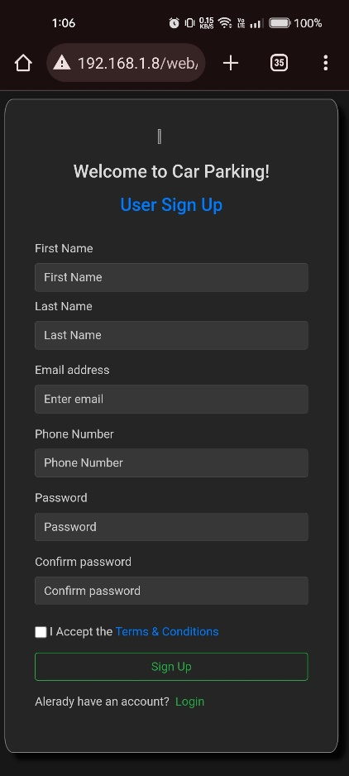

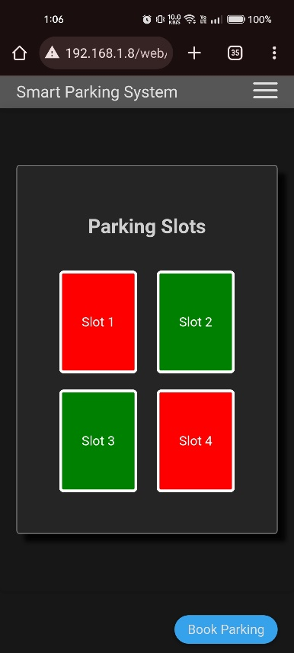

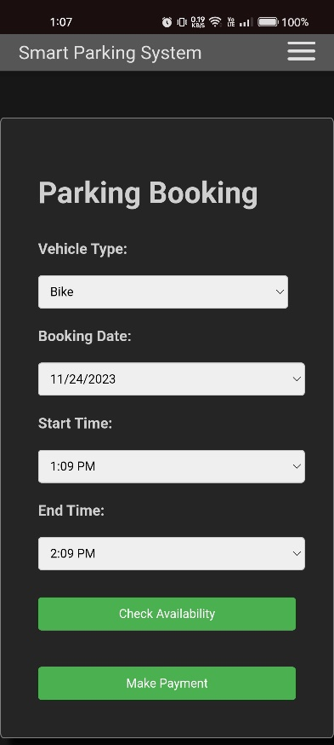

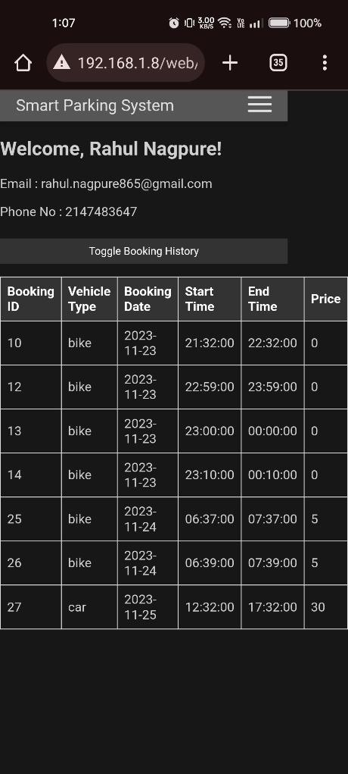

# **CONCLUSION**

A successful real time smart parking system was built for the management of cars in a parking slot. The important features that the system provides is a real time slot availiblity notification that will help the user to check when there is a slot in which they can park which will save their time and fuel to physically go at the place.Then the concept of UPI for the booking of a slot which will help to simplify the transaction and use digital money ,it being more secure and easy to handle nowdays.

A dynamic pricing has been sought in reponse to people paying large sums for entire day or half day of parking when they need only for 2-3 hours.Now they will be charged hour or half hourly and will be notified as and when their time is about to end.All these features will be presented on a website with a secure login system having the credentials of user and everything can be managed so that the user does not have to do different tasks at different places rather it is all under one roof and can be managed,modified by them easily.

# **FUTURE SCOPE**

• The future scope envisions dynamic evolution with cutting-edge technologies and features.

• Integration of advanced sensors like LiDAR and augmented computer vision for precision.

• Predictive AI algorithms for dynamic forecasting beyond occupancy predictions.

• Collaborations with smart city initiatives for seamless urban infrastructure connectivity.

• Augmented reality navigation to optimize the user experience.

• Exploration of blockchain, vehicular communication, and compatibility with autonomous vehicles.

• Emphasis on energy-efficient practices, customizable user profiles, and open APIs for sustainability.

• Community engagement mechanisms contribute to an intelligent, sustainable, and user-centric smart parking system, aligning with urban and technological evolution.

# **REFRENCES**

[1]” model of associate underground multi-storied machine-controlled automotive parking system” P. Eswara ,A V M Manikandan ,Saurabh 2013 IEEE International Conference ON rising Trends in Computing, Communication and engineering science (ICECCN)

[2]“IOT Based Smart Parking System using NODEMCU” TejasPund, HarshavardhanSidagam, Asif Pinjari,Journal of emerging technologies and innovative research(JETIR) December 2021

[3]” Smart Parking System based on IOT” Hardik Tanti, Pratik Kasodariya , Shikha Patel , Dhaval H. Rangrej , Laxmi Institute Of Technology, Sarigam in International Journal of Engineering Research & Technology (IJERT) may 05 ,2020

[4]“ IoT Based Smart Parking System for big Parking Lot Manikam Ramsamy, Sunil Govinda Solanki, Elang Natarajan, - IEEE on 2011 May 11

[5]” An Approach for IoT based Car Parking and Reservation system using Cloud “Vabhav Hans, Parminder Singh Sethi, Jatin Kira in 2015 International Conference on Green Computing and Internet of Things (ICGCIoT)

[6] “Review Paper on Smart Parking System”, Anusha, Arshitha M S, Anushri, Geetanjali Bishtannavar, Ms. Megha D Hegde. International Journal of Engineering Research & Technology (IJERT) ISSN: 2278-0181 Published by, www.ijert.org RTESIT - 2019 Conference Proceedings

[7] “A Research On Smart Vehicle Parking System”, Dipali Balmiki , Manas Singhal , Anupama Singh , Divyangi Tyagi. International Journal of Scientific Research and Management Studies (IJSRMS)

ISSN: 2349-3771 Volume 4 Issue 7, pg: 124-127

[8] “Detection of Empty Slots in Car Parking System Using Neural Network Method ”,Ahmad Ihsan, Nurul Fadillah, C R Gunawan, Mursyidah Mursyidah. IOP Conference Series: Materials Science and Engineering2020:854 012052

[9] P. Melnyk, S. Djahel and F. Nait-Abdesselam, "Towards a Smart Parking Management System for Smart Cities," 2019 IEEE International Smart Cities Conference (ISC2), Casablanca, Morocco, 2019, pp. 542-546, doi: 10.1109/ISC246665.2019.9071740

[10]” Radio frequency identification: technologies, applications,and research issues” Xiao, Y., Yu, S., Wu, K., Ni, Q., Janecek., C., Nordstad, J., 2006.. Wiley Journal of Wireless Communications and Mobile Computing.

[11] “Model for Intelligent Car Parking Monitoring and Assistance System”Asghar Ali Shah, G. M. (2019). Video Stitching with Localized 360..IJCSNS International Journal of Computer Science and Network Security , 6.

[12] “The Development of Smart Parking System based on NodeMCU 1.0 using the Internet of Things.” Anjari, L. & Budi, A. (2018) International Symposium on Materials and Electrical Engineering. 384. p. 1-6.

[13] “Understanding Smart and Automated Parking Technology.” Sajeev, A., Mallick, C., Vidwans, S. and Jog, Y. (2018) International Journal of u- and e- ssService, Science and Technology. 8 (2). p.251-262.

[14] “Park here! A smart parking based on smart phones’ embedded sensors and short range communication technologies ”Rosario Salpietro, Luca Bedogni, Marco Di Felice, LucianoBononi

[15] “ Study on Automated Car Parking System based on Microcontroller” Ahmed, M. and Wei, W. 2018. International Journal of Engineering Research & Technology IJERT. 3 (1). p. 256-259.

1.